**PRACTICAL NO.6**

**A.Connecting PHP with MongoDB and inserting, retrieving, updating and deleting.**

**Steps for configuration:-**

**Install dependencies**

Before you begin developing, ensure that you have the following dependencies installed on your local machine:

* [**PHP**](https://php.net/install) version 7.4 or later

Here it was already install with xampp

So I will just check the version of it.

Open **CMD** or **PowerShell**.

Navigate to your Apache bin folder. For example:

cd C:\xampp\php and executes php -v

output:-

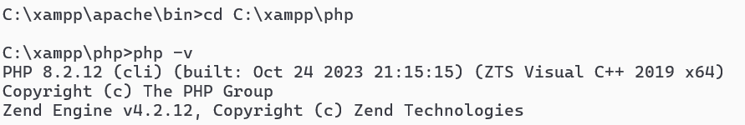

* [**Composer**](https://getcomposer.org/download/) version 2.0 or later

Then will install composer through above link.

You will get the composer-setup.exe file install it.

* [**pie**](https://github.com/php/pie/blob/main/docs/usage.md)

here you will get file called pie.phar download it.

Now copy this file to the C:\xampp\php

And now executes command below:-

pie install mongodb/mongodb-extension

**php pie.phar install mongodb/mongodb-extension**

IF you faced any issue related to **git** just install it from below path

<https://git-scm.com/download/win>

if there any missing dll like:-



if you faced any issue related to missing dll just install it manually and paste it into

C:\xampp\php\ext\

change name to like php_mongodb.dll

And also in php.ini and extension like below:-

extension=php_mongodb.dll

Now lets create a directory called php-quickstart for this project:

**mkdir php-quickstart**

and run the following commands to create a quickstart.php application file in the php-quickstart directory:

**cd php-quickstart**

**type nul > quickstart.php**

To install the MongoDB PHP Library, run the following command in your php-quickstart directory:

**composer require mongodb/mongodb**

After installing the library, include Composer's autoload.php file by adding the following code to the top of your quickstart.php file:

|  |
| --- |
| <?php |
|  |
| require_once __DIR__ . **'/vendor/autoload.php'**; |

<?php

require "C:/xampp/php/vendor/autoload.php";

$client=new MongoDB\Client("mongodb://localhost:27017");

$db=$client->phpdb;

$coll=$db->users;

$res=$coll->insertOne(["name"=>"GG","age"=> "21","email"=>"GG@gmail.com"]);

echo "inserted with data object ID:".$res->getInsertedId();

?>

**Output:**



**INSERT MANY RECORDS:-**

<?php

require "C:/xampp/php/vendor/autoload.php";

$client=new MongoDB\Client("mongodb://localhost:27017");

$db=$client->phpdb;

$coll=$db->users;

$res=$coll->insertMany([["name"=>"GG","age"=> "21","email"=>"GG@gmail.com"],

["name"=>"Rohit","age"=> "38","email"=>"Rohit@gmail.com"]

,

["name"=>"Alex","age"=> "23","email"=>"GS@gmail.com"]

]

);

foreach($res->getInsertedIds() as $id ) {

echo "inserted with data object ID:".$id."<br>";

}

?>

**Output:**

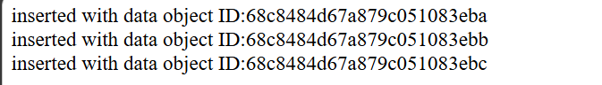

**DELETE RECORDS:-**

<?php

require "C:/xampp/php/vendor/autoload.php";

$client=new MongoDB\Client("mongodb://localhost:27017");

$db=$client->phpdb;

$coll=$db->users;

// Delete one user here:-

$res = $coll->deleteOne(["name" => "GG"]);

echo "Deleted " . $res->getDeletedCount() . " document(s)  with deleteOne query<br>";

// Delete all users with age < 30

$res = $coll->deleteMany(["age" => ['$lt' => 30]]);

echo "Deleted " . $res->getDeletedCount() . " document(s)  with deleteMany query";

?>

**Output:**

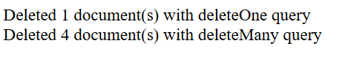

**Retrieving query:-**

<?php

require "C:/xampp/php/vendor/autoload.php";

$client=new MongoDB\Client("mongodb://localhost:27017");

$db=$client->phpdb;

$coll=$db->users;

$user=$coll->findOne(array("name"=> "karan"));

if($user)

{

echo "Name: " . $user["name"] . "<br>";

    echo "Age: " . $user["age"] . "<br>";

    echo "Email: " . $user["email"] . "<br>";

}

else

{echo "No user found";

}

?>

**Output:**

Name: GG

Age: 21

Email: GG@gmail.com

**Findmany**

<?php

require "C:/xampp/php/vendor/autoload.php";

$client=new MongoDB\Client("mongodb://localhost:27017");

$db=$client->phpdb;

$coll=$db->users;

$cursor = $coll->find(["age" => ['$gt' => 25]]);

foreach ($cursor as $doc) {

    echo $doc["name"] . " (" . $doc["age"] . ")<br>";

}

?>

**Output:**

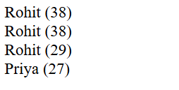

**UPDATE DATA:-**

<?php

require "C:/xampp/php/vendor/autoload.php";

$client=new MongoDB\Client("mongodb://localhost:27017");

$db=$client->phpdb;

$coll=$db->users;

$res1 = $coll->updateOne(

    ["name" => "GG"],['$set' => ["email" => "GG123@gmail.com"]]

);

echo "Matched: " . $res1->getMatchedCount() . ", Modified: " . $res1->getModifiedCount() . "<br>";

$res2 = $coll->updateMany(

    ["name" => "Rohit"],['$set' => ["age" => 40]]

);

echo "Matched: " . $res2->getMatchedCount() . ", Modified: " . $res2->getModifiedCount() . "<br>";

?>

**Output:**

